**Task Description:** To optimize the Docker image size, consider utilizing Docker Slim or implementing multi-stage builds. These approaches can significantly reduce the container's footprint, enhancing containerization efficiency.

For the whole task, I’m using Docker Desktop and I’m using multi-stage build method.

Step 1: First, I created an image with a single stage dockerfile.

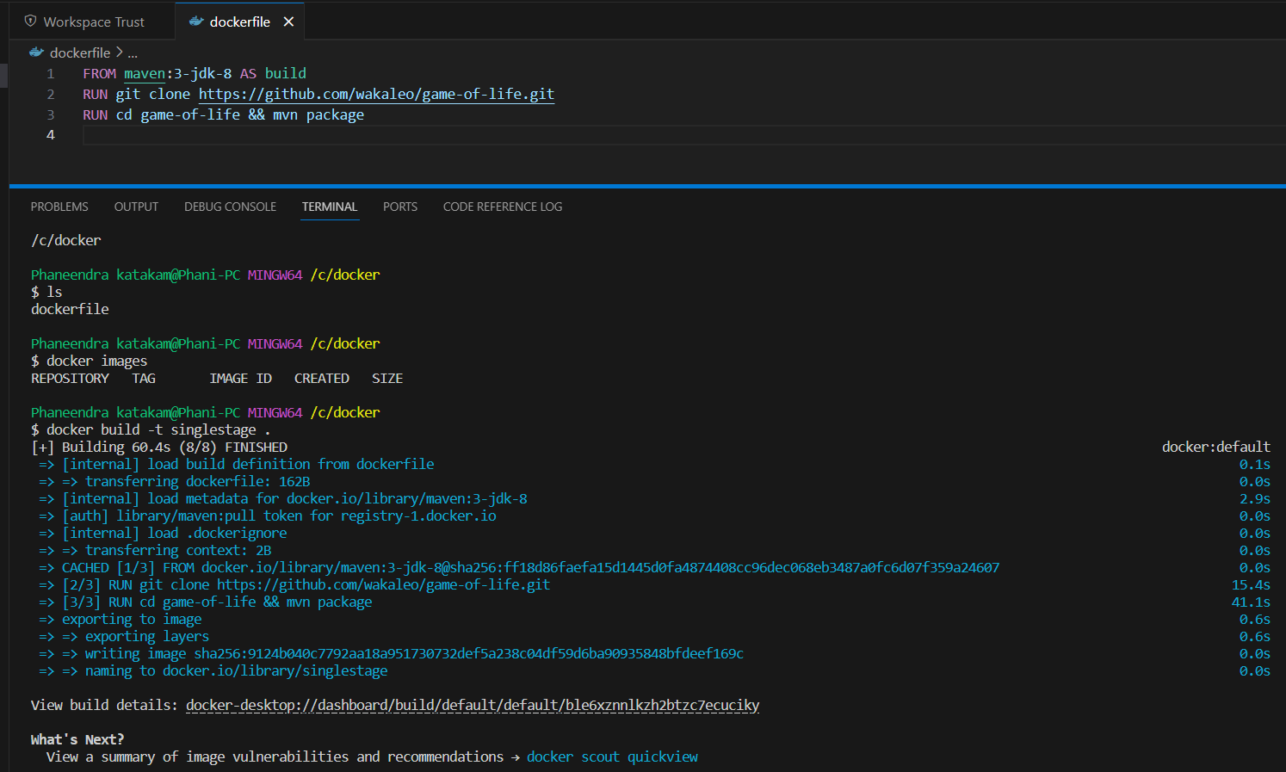

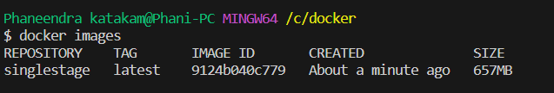

The Single Stage Image created with a size of 657mb.

Step 2: To reduce the docker image size, now I crated an image with multi stage dockerfile.

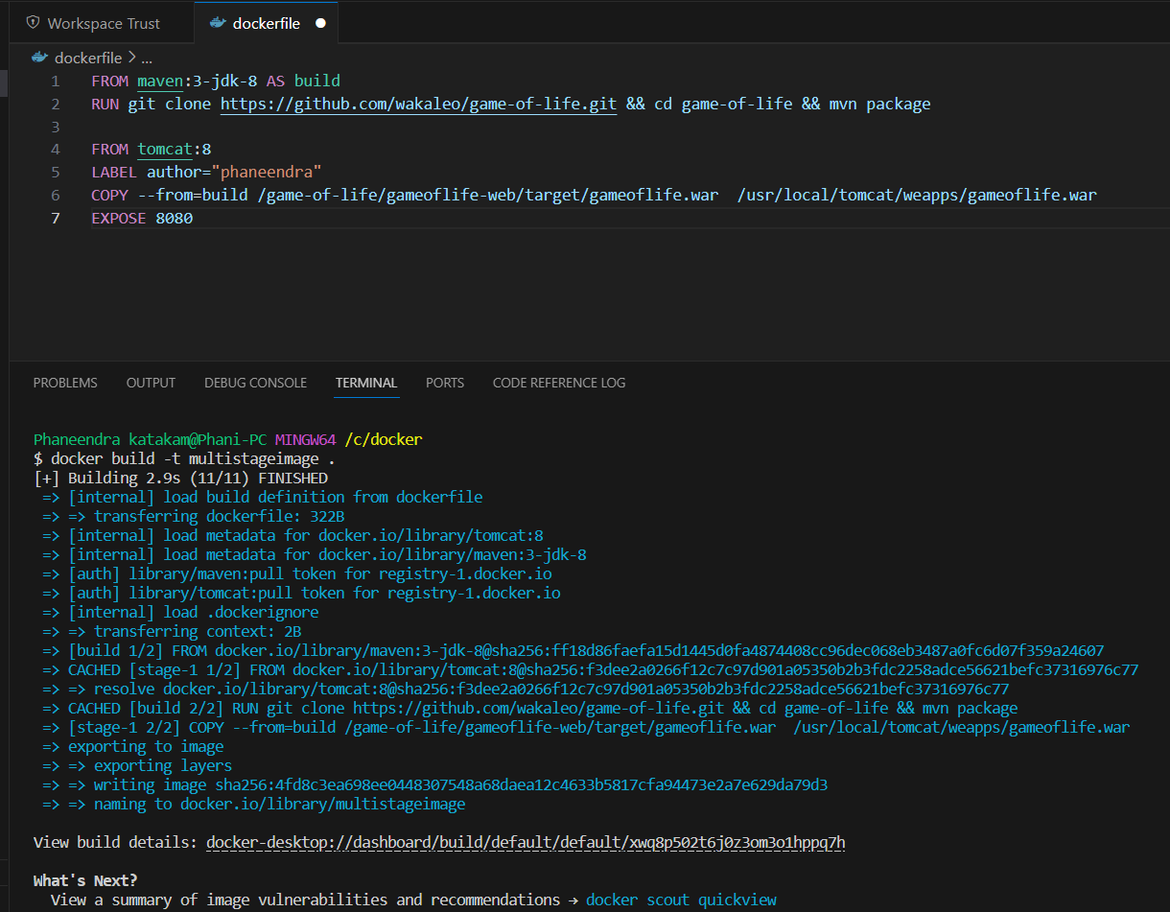



Now the image size reduced is reduced to half of the previous one.